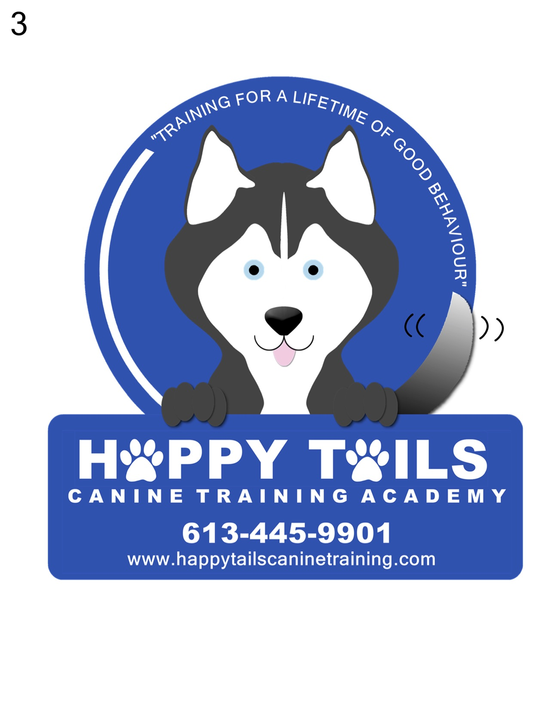

Revised November 19, 2020.

COVID-19 LIABILITY WAIVER

If you attend classes with Michelle St Germain of Happy Tails Canine Training Academy, you agree to the following liability form.
- I acknowledge the contagious nature of the Coronavirus/COVOD-19 and the public health authorities recommendation to practice physical distancing.
- I further acknowledge that Michelle St Germain of Happy Tails Canine Training has put into place preventive measures to reduce the spread of the Coronavirus/COVID-19.
- I further acknowledge that Michelle St Germain of Happy Tails Canine Training cannot guarantee that I will not become infected with the Coronavirus/COVID-19 while doing in person Dog obedience classes. I understand that the risk of becoming exposed to and/or infected by the Coronavirus/COVID-19 may result from the actions, omissions or negligence of myself and others, including but not limited to Michelle St Germain, owner of Happy Tails Canine Training, and other clients/dog owners and their families.
- I voluntarily seek services provided by Michelle St Germain of Happy Tails Canine Training and acknowledge that I am increasing my risk to the exposure to the Coronavirus/COVID-19. I acknowledge that I must comply with all the set procedures to reduce the spread while attending a Happy Tails Canine Training group class.

PLEASE CHECK ALL THAT APPLY TO YOUR CURRENT STATE OF HEALTH:

I attest that:

- I am not experiencing any symptom(s) of illness such as cough, shortness of breath/difficulty breathing, fever, chills, repeated shaking with chills, muscle pain, headache, sore throat or new loss of taste or smell.
- I have not travelled internationally within the last 14 days.
- I do not believe I have been exposed to someone with suspected and/or confirmed case of the Coronavirus/COVID-19
- I have not been diagnosed with Coronavirus/COVID-19.
- I am following all recommended guidelines set out by the Eastern Ontario Health Unit (EOHU) as much as possible and limiting my exposure to the Coronavirus/COVID-19.
- I hereby release and agree to hold Michelle St Germain of Happy Tails Canine Training from, and waive on behalf of myself, my heirs and any personal representatives or any and all causes of action, claims, demands, damages, costs, expenses and compensation of damages or loss to myself and/or property that may be caused by any act, or failure to act by Michelle St Germain, of Happy Tails Canine Training or that may otherwise arise in connection with any services received from Happy Tails Canine Training. I understand that this release discharges Michelle St Germain of Happy Tails Canine Training from any liability or claim that I, my heirs or any personal representatives may have against the training facility with respect to any bodily injury, illness, death, medical treatment or property damage that may arise from, or in connection to, any services received from Michelle St Germain of Happy Tails Canine Training.

Please Print and sign name and date

EMAIL AND PHONE NUMBER must be provided for the purpose of trace contact record keeping for every training session attended.
Please print and fill out this form each time you attend a dog training session.

STOP THE SPREAD OF COVID-19 BY FOLLOWING THE LISTED PRACTICES WHILE ATTENDING OUR TRAINING CLASSES:

We are taking many safety measures to keep our clients and teachers safe. If everyone can follow these protocols, we can return to indoor puppy classes. These protocols may change at any given time. We will continue to follow the advice of the Eastern Ontario Health Unit as this pandemic continues and develops. We appreciate everyone’s support with the measures we are taking. Please use these protocols when deciding if group indoor puppy classes is right for you and your family at this time.

CLASS SIZES: Maximum 5 dogs (1handler per dog)

Arrive at the class no earlier than 5-10 minutes. You may wait outside the front doors 6 feet apart and enter when the instructor opens the door.

Teacher will wear a mask the entire class.

Please maintain a 2m distance from other classmates while in class.

WASHROOMS are off limits at this time

Bring a personal water bowl for your dog and plenty of treats.

BETWEEN CLASSES: All high touch surfaces in the hall will be disinfected. The floor will only be done at the end of the evening.

WHAT HAPPENS IF WE GET LOCKED DOWN AGAIN:
If the government or the EOHU requires us to lock down again, we will switch over to ZOOM online classes for the remainder of the session. The remainder of the classes can also be held aside for when the classes commence again. Refunds can be issued if necessary.

If you see something you are concerned about or that you believe we are missing, please bring it to our attention.

SUMMARY OF THE RULES AND REGULATIONS AS PERTAINING TO COVID-19 IN GROUP CLASS SETTINGS

- WAIT IN YOUR CAR UNTIL THE PREVIOUS CLASS IS OUT OF THE BUILDING AND THE INSTRUCTOR HAS HAD A CHANCE TO SANITIZE IT.

- CLASSES WILL ENTER THE BUILDING THROUGH THE FRONT DOOR AND EXIT THROUGH THE SIDE DOOR

- DO NOT ENTER IF YOU HAVE ANY FLU LIKE SYMPTOMS

- MASKS MUST BE WORN DURING THE ENTIRE CLASS.

- ONLY ONE MEMBER OF THE FAMILY IS PERMITTED TO COME TO THE CLASS PER WEEK.

- USE HAND SANITIZERS IN THE BUILDING WHEN YOU ARRIVE AND BEFORE YOU LEAVE (LOCATED AT BOTH DOORS)

- COUGH OR SNEEZE INTO YOUR ARM OR A TISSUE

- AVOID TOUCHING YOUR EYES, MOUTH AND NOSE

- MAINTAINING A 2 METER DISTANCE BETWEEN THE PEOPLE IN THE CLASS.

- AVOID TOUCHING OTHER PEOPLE’S DOGS

- LOOK FOR MARKERS ON THE WALLS

- LIMIT TOUCHING SURFACES

- IF YOU MISS A CLASS PLEASE EMAIL OR CALL US TO LET US KNOW WHY YOU WERE UNABLE TO ATTEND.

IF AT ANY TIME THE TRAINING CLASSES GET SUSPENDED. CLASSES WILL BE MADE UP AT A LATER DATE OR A CREDIT WILL BE GIVEN.

